**Creating a new React Application :**

1. Install Create-react-app by running the command in the command prompt: 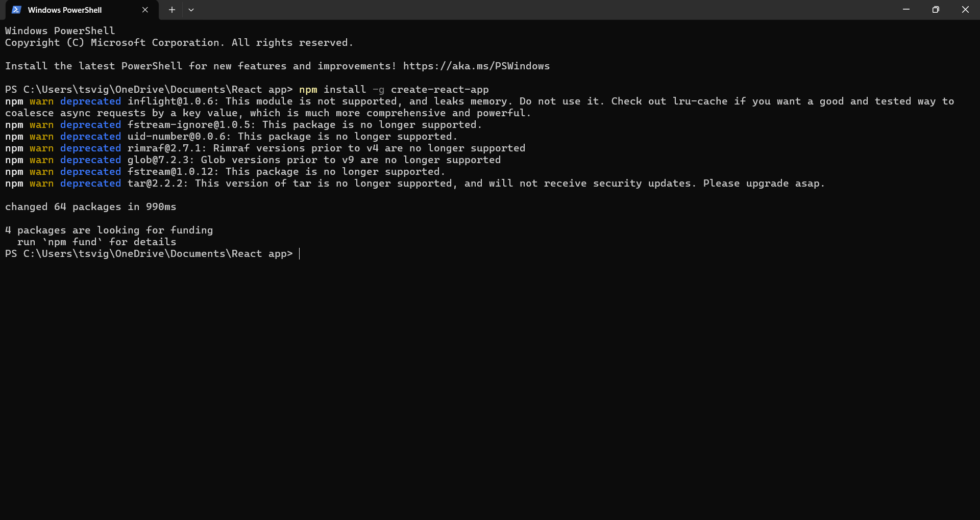
2. To create a React Application with the name of “myfirstreact” 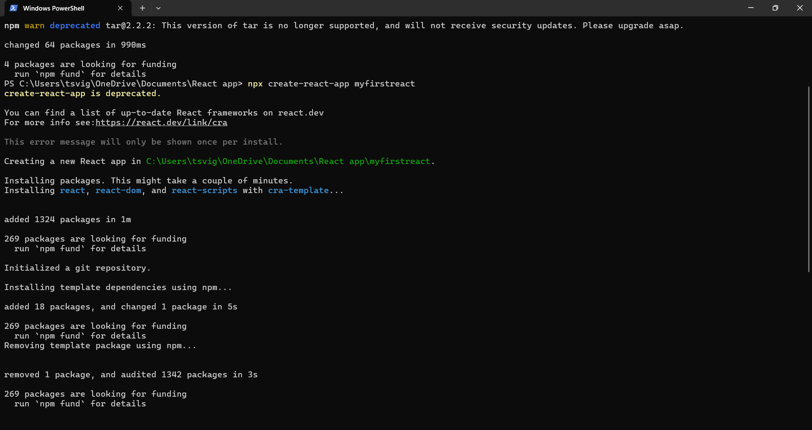
3. Once the App is created, navigate into the folder of myfirstreact 
4. Opening the App.js file in Src Folder of myfirstreact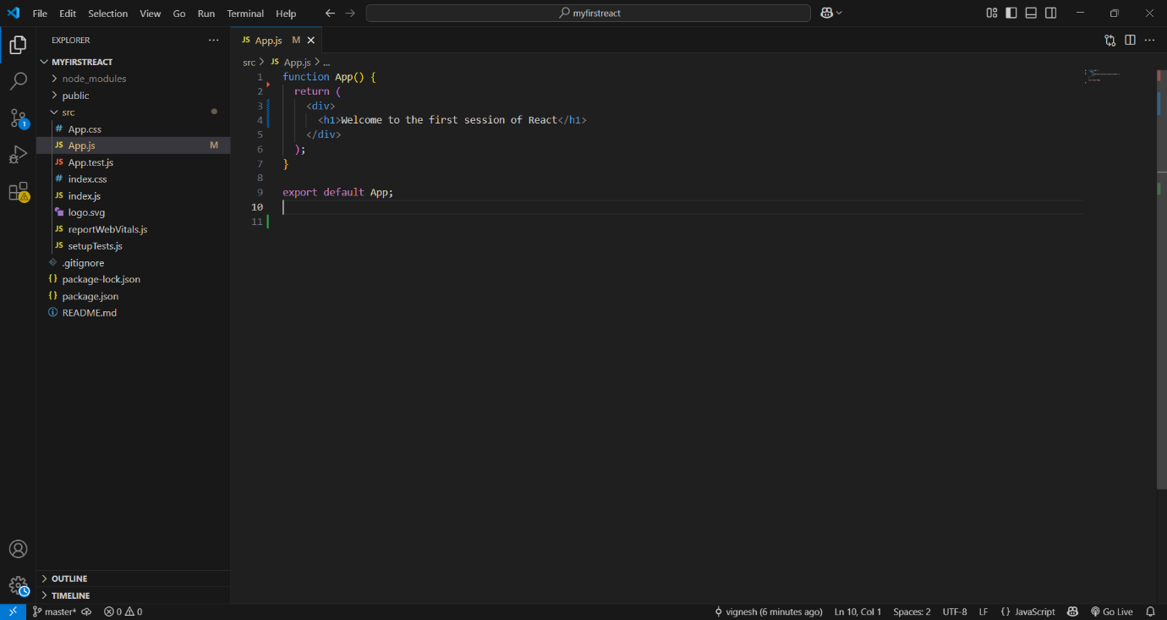
5. Running the App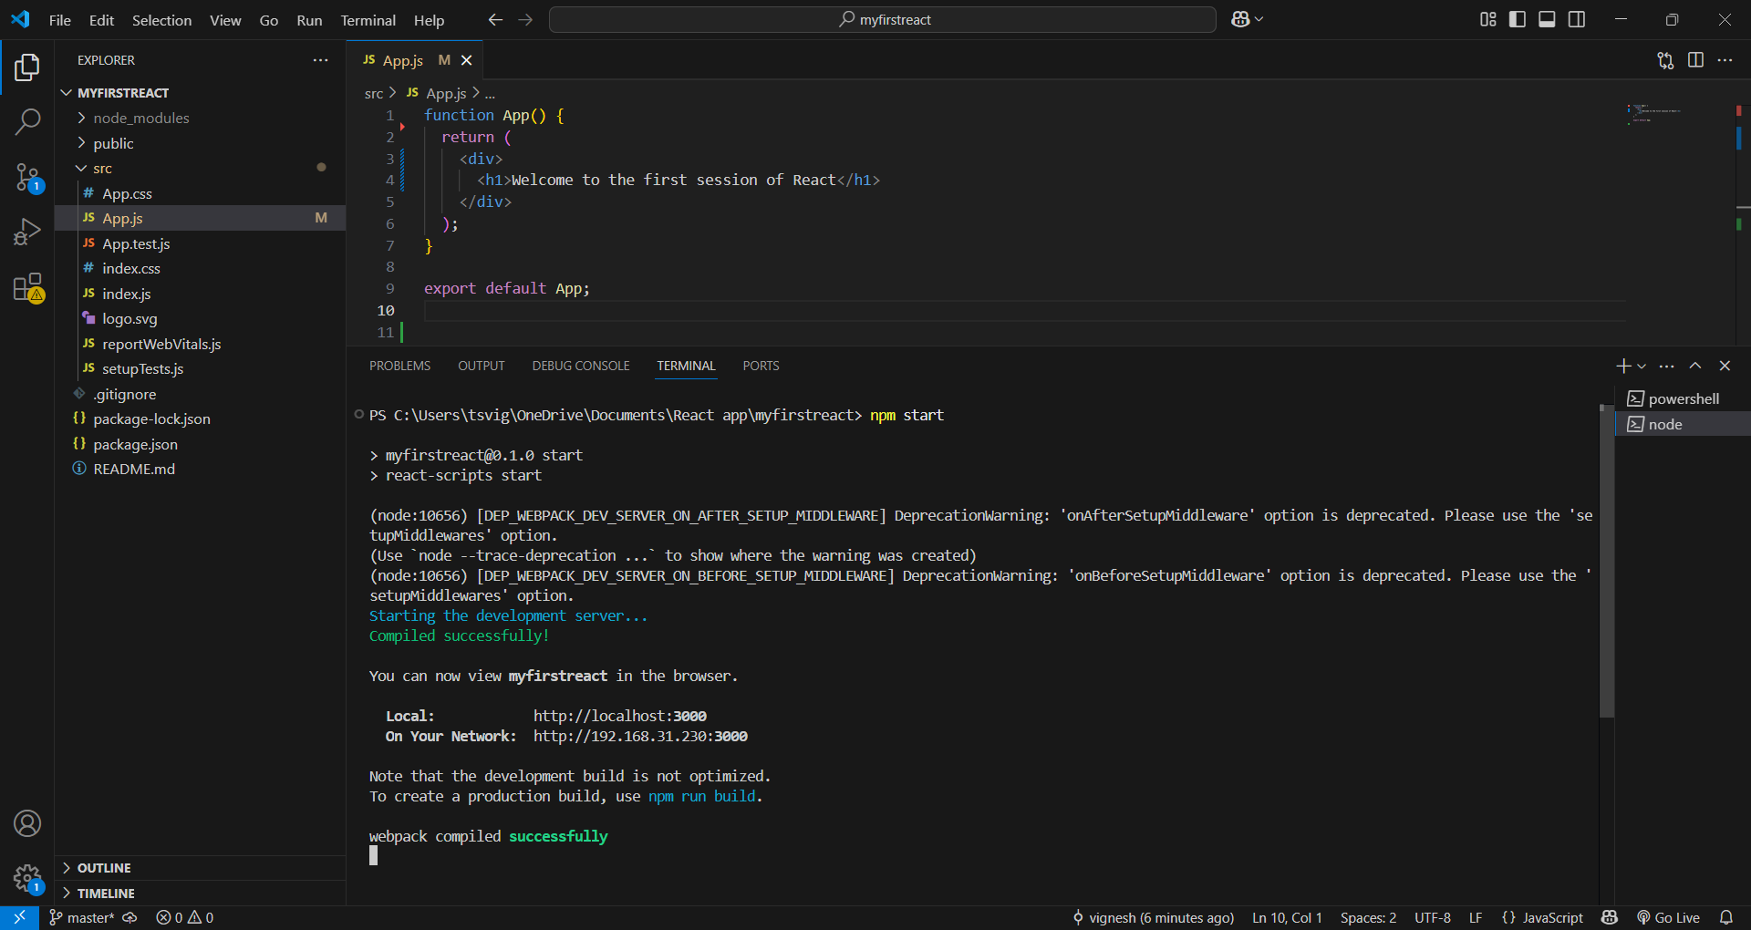
6. React app Output